Venn, Tyron, Dr (from University of Montana website)
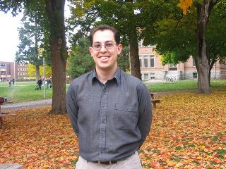
Bachelor of Science (Forestry), Australian National University, 1997. Bachelor of Economics, Australian National University, 1998. Postgraduate Economics Honours (1st Class), University of Queensland, 1999.
Doctor of Philosophy in Economics, University of Queensland, 2004.
Born in Brisbane, Queensland, Australia. Exposed to natural resource economics during his second year of university study and enrolled in a combined forestry and economics degree the following semester.
His economics honours research gave him the opportunity to work with Steve Harrison of The University of Queensland and took him to the Islands of Mindanao and Leyte in the Philippines.
During a 10-month deferment of his PhD, he undertook contract work for the Queensland Forestry Research Institute where he examined small-scale forestry opportunities for graziers in western Queensland and the economic (as opposed to financial) value of hardwood plantations in Queensland. Following submission of his PhD, Tyron had the honour and pleasure of working with John Quiggin as a Postdoctoral Research Fellow on water management in Australia’s Murray-Darling Basin. In 2005 he commenced employment at The University of Montana.

